Log in to Team Unify
www.teamunify.com/vvfmr
Select Events

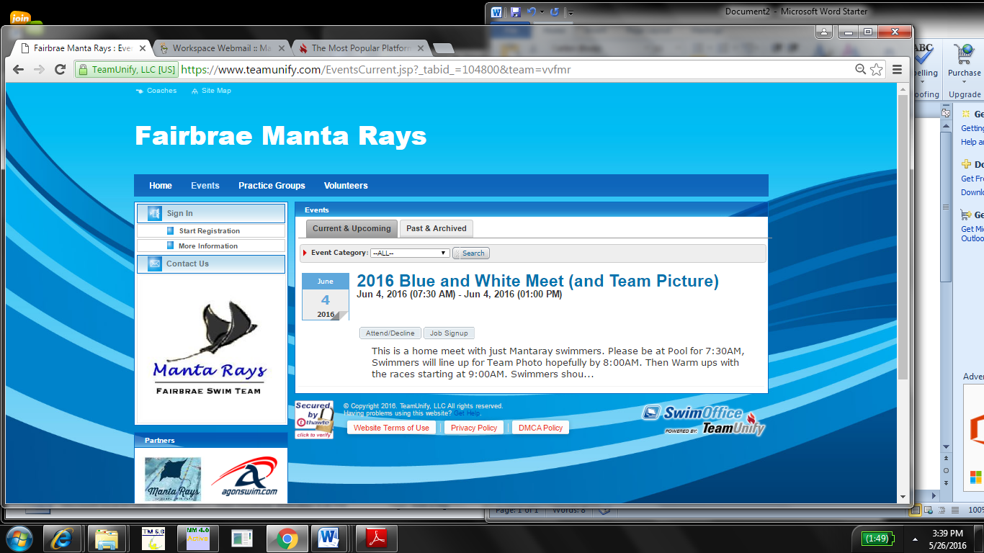
Volunteer Sign UP
Swimmer Sign UP

For Swimmer Sign Up select Attend/Decline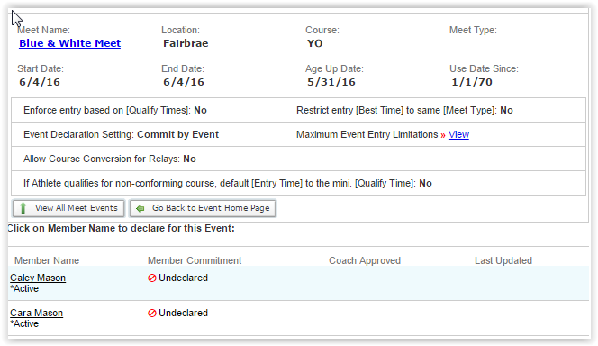
Select Your Swimmer

Change Declaration to Yes ( or No If you are unable to attend)
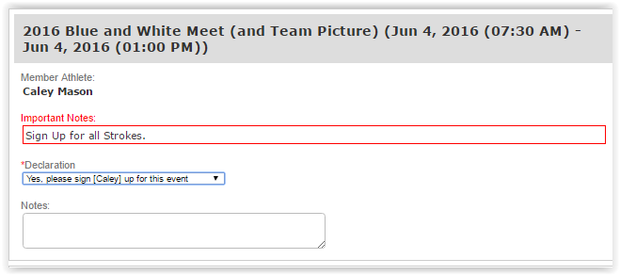
Select Yes or No

Selecting Yes will add more fields to page which will allow you to enter the events your swimmer will participate in.
NUMBER OF EVENTS
In the Blue and White meet your swimmer should enter all events, this gives them a “seed” time allowing them to get points for the team for improving on the seed time during the season. In all other meets the swimmer is only allowed to swim 3 events. If you have a younger swimmer only 4 events will be listed.
Event Selection
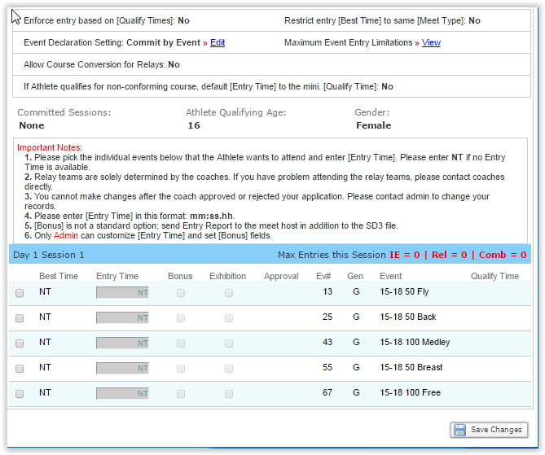
Event List
Select Events
Do Not Enter any times here
SAVE CHANGES

After saving changes you should return to the previous menu and see the following updates
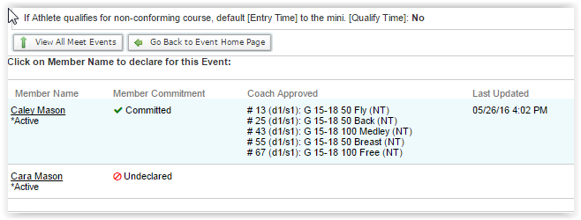

Return to Events Page and select Job Signup and follow instructions to sign up
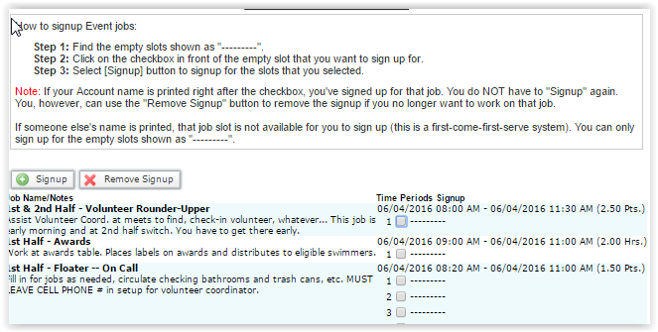

You should also receive email confirmation what events your swimmer is signed up for
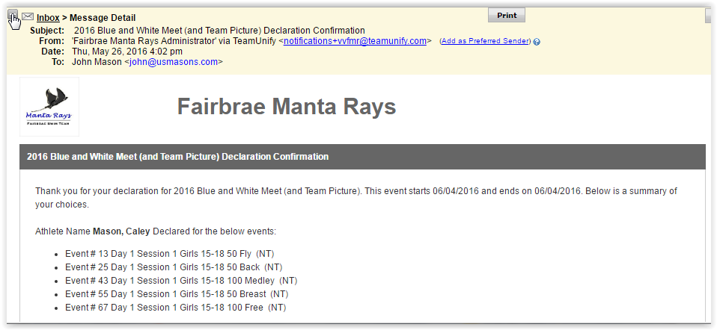

Any Problems signing up Contact mantaraysdata@yahoo.com

